Financial summary
The FRC is a statutory body under the Family Responsibilities Act 2008 and for the purposes of the:
- Financial Accountability Act 2009
- Financial and Performance Management Standard 2019
- Statutory Bodies Financial Arrangements Act 1982.
This summary provides an overview of the FRC’s financial performance for 2021-22 and a comparison to 2020-21. A comprehensive set of 2021-22 financial statements covering all aspects of the Commission’s activities commences on page 88.

Our overall performance
Table 13: Summary of financial performance
Summary statement | 30 Jun 2022 | 30 Jun 2021
Summary statement | $000 | $000
Income | 4,245 | 4,184
Less: expenses | 3,964 | 3,829
Operating surplus | 281 | 355

Income
Table 14: Summary of income by type
Income by type | 30 Jun 2022 | 30 Jun 2021
Income by type | $000 | $000
State Government funding | 2,418 | 2,359
Australian Government funding | 1,800 | 1,800
Other revenue | 27 | 25
Total | 4,245 | 4,184
The increase in State Government funding is the application of a CPI increase. Other revenue increased this year and is primarily interest received. Interest received was marginally higher this year (increase of $1K) with the remainder of the increase due to receipt of reimbursement for staff jury duty ($1K).

Expenses
Table 15: Summary of expenses by type
Expenses by type | 30 Jun 2022 | 30 Jun 2021
Expenses by type | $000 | $000
Employee expenses | 2,967 | 2,827
Supplies and services | 910 | 938
Depreciation and amortisation | 40 | 19
Finance/borrowing costs | 3 | 2
Other expenses | 44 | 43
Total | 3,964 | 3,829
Employee expenses (representing 74.8 percent) of total expenditure (2021: 73.8 percent) increased in 2021-22 due to the application of two wage increases during the year (one of which was deferred from 2020-21 due to Queensland Government COVID-19 austerity measures), an increase in the superannuation rate for the Commissioner and Local Commissioners as well as the resulting increases in payroll tax and other payroll oncosts. Savings in employee expenses for Local Commissioners due to cancelled conferences have been offset by the above increases as well as the cost of staff returning from maternity leave.
The decrease in supplies and services is due to the reduction in employment agency costs following the conversion to tenure of previous agency staff in line with directive 09/20. This reduction was offset by increased legal and consultancy expenses.
Increased depreciation and amortisation and finance/borrowing costs relate to Commission property and equipment leases that have been recognised as right-of-use assets and lease liabilities in accordance with Accounting Standards.
The expenditure of the FRC can be categorised as follows:
- Community operations – further broken down into:
  - On-the-ground community operational expenses including the operational expenses in each of the five communities to conduct conferences and hearings, prepare and monitor case plans for clients for attendance at community support services and prepare and monitor income management agreements and orders.
- Support and facilitation expenses including costs associated with facilitating the holding of conferences and hearings in the five communities, providing support to the Local Commissioners and Local Registry Coordinators to hold conferences and hearings, assisting with the on-going monitoring of case plans for clients through the provision of data and other information and processing income management where considered necessary.
- Corporate governance includes finance, statistical reporting, corporate governance, training and other administrative functions to ensure the effective and efficient operations of the Commission.

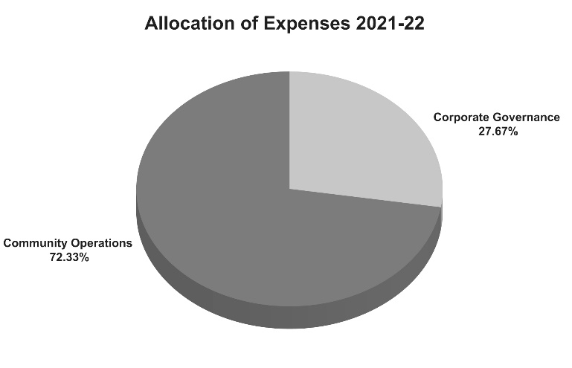
The allocation of the FRC’s costs in 2021-22 based on the above was:
Graph 13: Allocation of expenses
1 July 2021 to 30 June 2022

These FRC expenses can be further categorised as front-line and non-frontline in accordance with the Queensland Public Service Commission definitions.
Community operations and conference facilitation expense are frontline expenses and are conducted on-the-ground in community by Local Registry Coordinators and Local Commissioners, and in the Cairns Registry office to support the holding of FRC conferences and hearings across the five communities. The Local Commissioners are paid sessional fees per Level 3 Adjudication and determination in accordance with the Remuneration Procedures for Part-Time Chairs and Members of Queensland Government Bodies. When engaged, the Local Commissioners could be holding conferences and/or hearings, serving notices, attending meetings or undertaking professional development.
This work includes work that is undertaken to support conference prioritisation and scheduling and preparation of client records for consideration by the Local Commissioners, processing decisions made and preparing and monitoring case plans and/or income management. This work is essential to support the Local Commissioners when conferencing which is central to the FRC’s role and could not be efficiently or easily undertaken in the communities themselves.
For the 2021-22 year, 72.33 percent of FRC expenses support frontline operations, while 27.67 percent support corporate governance.

Our position
Total assets as at 30 June 2022 consisted of current assets of cash, prepayments and receivables in addition to non-current plant and equipment and right-of-use assets.
Total liabilities as at 30 June 2022 consisted of payables, accrued employee benefits and lease liabilities.
Table 16: Statement of financial position
Statement of financial position | 30 Jun 2022 | 30 Jun 2021
Statement of financial position | $000 | $000
Total assets | 3,960 | 3,640
Total liabilities | 431 | 392
Net assets | 3,529 | 3,248
Total equity | 3,529 | 3,248

